MR202
SEM (continued)
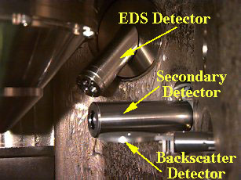

Analogy with ‘seeing’
Electrons
Detector
Eye
Light Source
Specimen
Specimen
Detectors
Backscattered Electron Detectors – Dedicated
Autrata Detector – uses a YAG crystal
Everhart-Thornley Detector
Positive Bias – for SE+BSE
Negative Bias – for BSE alone
Specimen Current

